**PROJECT-2: STARBUCKS COFFEE COMPANY**

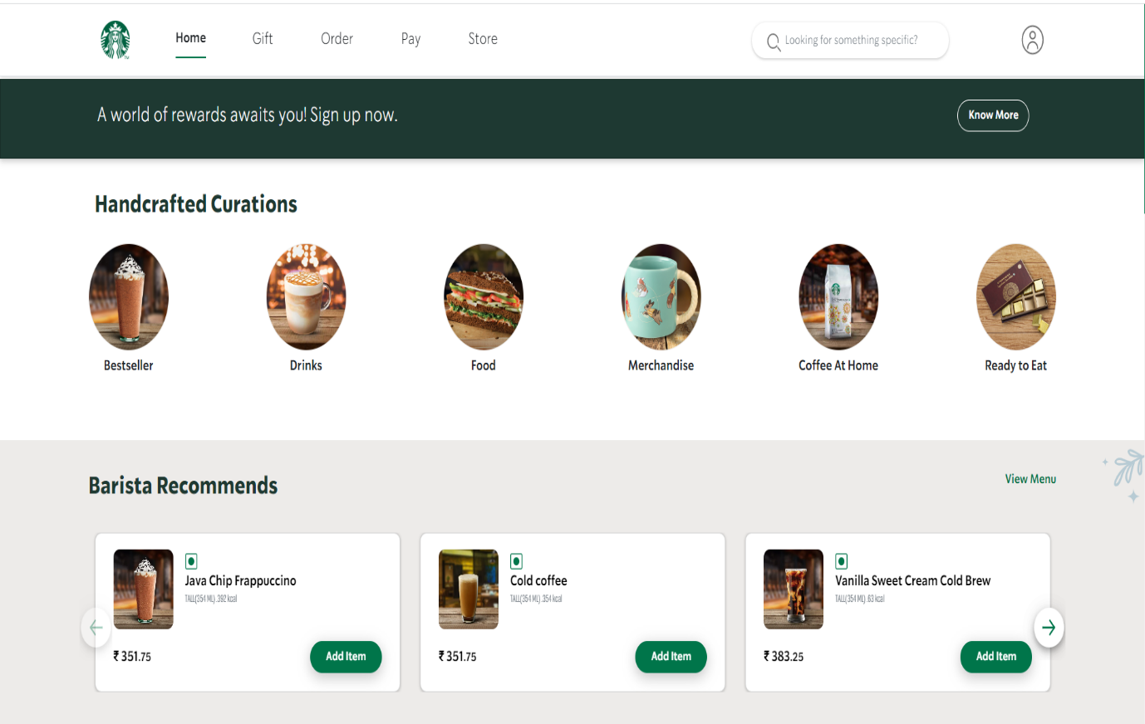

**ABOUT STARBUCKS:**

Starbucks began in 1971 along the cobblestone streets of Seattle’s historic Pike Place Market. It takes many hands to craft the perfect cup of coffee – from the farmers who tend to the red-ripe coffee cherries, to the master roasters who coax the best from every bean, and to the barista who serves it with care. We are committed to the highest standards of quality and service, embracing our heritage while innovating to create new experiences to savor.

In January 2011, Starbucks Corporation and Tata Coffee announced plans to begin opening Starbucks locations in India.

**SECTIONS IN OUR PROJECT:**

**Home page:**

* Menu bar with a login section.
* Handcrafted Curations(links to orders page)
* Barista Recommends(a mini menu)
* About Starbucks and
* A footer

**Gift page:**

* A menu bar
* Gift cards
* Anytime
* Congratulations

**Order page:**

* A menu bar with search bar to search Starbucks locations.
* A complete menu of Starbucks that is a reference page to Handcrafted Curations in home page

**Pay page:**

A pop-up login with sign up details like User name & Password.

**Store page:**

Enables us to search for nearby Starbucks stores based on entered locations.

* A Search bar
* Starbucks locations list
* And a pop-up map according to the location.

**TECHNOLOGIES USED:**

Front-End:

* Html
* Css
* Bootstrap
* React

Dynamic:

1. Javascript

2. Ci/cd with AWS

3. Login and Logout (oauth and jwt)

Database:

* Mongodb
* Json Data

Code compilers:

* Visual studio code
* Git bash
* Git hub
* Node js.